**e-Banking System**

**A PROJECT REPORT**

***in partial fulfillment for the award of the degree***

***of***

**BACHELOR OF TECHNOLOGY**

**IN**

**COMPUTER SCIENCE AND ENGINEERING**

***Under the Guidance of***

**JOYJIT GUHA BISWAS**

***Project Carried Out At***



**Ardent Computech Pvt Ltd (An ISO 9001:2008 Certified)**

**CF-137, Sector - 1, Salt Lake City, Kolkata - 700 064**

***Submitted By***

***AMANDEEP SINGH***

***ARYAN RAJ***

***ABHINAV KUMAR***

***KRISHNA KAMAL MANDAL***

***SUSMITA DUTTA***

***SAIBAL KUMAR PRADHAN***



**NATIONAL INSTITUTE OF INFORMATION TECHNOLOGY**

**In association with**



***(Note:* *All entries of the proforma of approval should be filled up with appropriate and complete information. Incomplete proforma of approval in any respect will be summarily rejected.)***

1. Title of the Project:  **e-Banking System**

2. Project Members: 1. Amandeep Singh, 2. Aryan Raj 3. Abhinav Kumar, 4. Susmita Dutta

5. Krishna Kamal Mandal,6. Saibal Kumar Pradhan

3. Name and Address of the Guide: **MR. JOYJIT GIHA BISWAS**

Subject Matter Expert & Assistant Technical Head (PHP Domain)

Ardent Computech Pvt Ltd (An ISO 9001:2008 Certified)

CF-137, Sector - 1, Salt Lake City, Kolkata - 700 064

PhD**\***  M.Tech.**\*** B.E\***/**B.Tech.*MCA**\*** M.Sc.**\***

Y

4. Educational Qualification of the Guide:

5. Working / Training experience of the Guide: **3 Years**

6. Project Version Control History

|  |  |  |  |
| --- | --- | --- | --- |
| **Version** | **Primary Authors** | **Description of Version** | **Date Completed** |
| Final | Amandeep Singh, Aryan Raj, Abhinav Kumar, Krishna Kamal Mandal, Susmita Dutta | Project Report | 24th July, 2017 |

1. 2.

3. 4.

5.

Signatures of Team Members Signature of Approval

Date: Date:

**For Office Use Only Mr. Joyjit Guha Biswas**

Project Proposal Evaluator

**Approved**

**Not Approved**

**Project Responsibility Form**

**e-Banking System**

|  |  |  |  |  |  |  |  |  |  |  |  |  |  |  |  |  |  |  |  |  |  |  |  |  |  |
| --- | --- | --- | --- | --- | --- | --- | --- | --- | --- | --- | --- | --- | --- | --- | --- | --- | --- | --- | --- | --- | --- | --- | --- | --- | --- |
| |  |  |  |  | | --- | --- | --- | --- | | GROUP NO. | SL.NO. | NAME OF MEMBER | RESPONSIBILITY | | 1 | 1 | Amandeep Singh | Project Leader & Documentation, Coding | | 2 | Aryan Raj | Coding & Designing, Testing and Maintenance | | 3 | Abhinav Kumar | PPT, Documentation, Presentation | | 4 | Krishna Kamal Mandal | Designing, Coding, Maintenance | | 5 | Susmita Dutta | System Analysis | | 6 | Saibal Kumar Pradhan | System Analysis ,Testing |   Each group member must participate in project development and developing the ideas for the required elements. Individual group members will be responsible for completing tasks which help to finalize the project and the performance. All group members must be assigned a task. | |  | | --- | |  | |

Date:

Name of the Students

1. Amandeep Singh
2. Aryan Singh
3. Abhinav Kumar
4. Krishna Kamal Mandal
5. Susmita Dutta
6. Saibal Kumar Pradhan

Signatures of the students

a. b.

c. d.

e. f.

**DECLARATION**

We hereby declare that the project work being presented in the project proposal entitled

**“(e-Banking System)”** in partial fulfilment of the requirements for the award of the degree of **BACHELOR OF TECHNOLOGY IN COMPUTER SCIENCE AND ENGINEERING** at **ARDENT COMPUTECH PVT. LTD, SALTLAKE, KOLKATA, WEST BENGAL,** is an authentic work carried out under the guidance of **MR. Joyjit guha biswas**. The matter embodied in this project work has not been submitted elsewhere for the award of any degree of our knowledge and belief.

Date:

Name of the Students

1. Amandeep Singh
2. Aryan Raj
3. Abhinav Kumar
4. Krishna Kamal Mandal
5. Susmita Dutta
6. Saibal Kumar Pradhan

Signature of the students

a.

b.

c.

d.

e.

f.



**Ardent Computech Pvt Ltd (An ISO 9001:2008 Certified)**

**CF-137, Sector - 1, Salt Lake City, Kolkata - 700 064**

**CERTIFICATE**

This is to certify that this proposal of minor project entitled **“e-Banking System”** is a record of bona fide work, carried out by **1. Amandeep singh 2. aryan raj 3. abhinav kumar 4. Krishna kamaal mandal** **5. susmita dutta** and **6. Saibal Kumar Pradhan** under my guidance at **Ardent Computech Pvt Ltd**.In my opinion, the report in its present form is in partial fulfilment of the requirements for the award of the degree of **BACHELOR OF TECHNOLOGY IN COMPUTER SCIENCE AND ENGINEERING** and as per regulations of the **Ardent*®.*** To the best of my knowledge, the results embodied in this report, are original in nature and worthy of incorporation in the present version of the report.

**Guide / Supervisor**

**_____________________________________________________________**

**Mr. JOYJIT GUHA BISBAS**

Subject Matter Expert & Assistant Technical Head (PHP Domain)

Ardent Computech Pvt Ltd (An ISO 9001:2008 Certified)

CF-137, Sector - 1, Salt Lake City, Kolkata - 700 064

**ACKNOWLEDGEMENT**

Success of any project depends largely on the encouragement and guidelines of many others. We take this sincere opportunity to express our gratitude to the people who have been instrumental in the successful completion of this project work.

Our heartfelt thanks to **…………………..**, HOD of Department of Computer Science, Netaji Subhash Engineering College, for providing us the opportunity to develop the project at Ardent Computech Pvt.Ltd.

We would like to show our greatest appreciation to Mr. Joyjit Guha Biswas, Project Manager at Ardent, Kolkata. We always feel motivated and encouraged every time by his valuable advice and constant inspiration; without his encouragement and guidance this project would not have materialized.

We wish to express our deep sense of gratitude to our internal guide, **………………….**, Professor, NATIONAL INSTITUTE OF INFORMATION TECHNOLOGY for her able guidance and useful suggestions, which helped us in completing the project work in time.

Words are inadequate in offering our thanks to the other trainees, project assistants and other members at Ardent Computech Pvt. Ltd. for their encouragement and cooperation in carrying out this project work. The guidance and support received from all the members and who are contributing to this project, was vital for the success of this project.

**TABLE OF CONTENTS**

|  |  |  |
| --- | --- | --- |
| **S.NO.** | **Name of the Topic** | **Page No.** |
| **1.** | **Company Profile** | **9** |
|  |  |  |
| **2.** | **Introduction** | **11-16** |
| 2.1 | Objective | 17 |
| 2.2 | Scope | 18 |
|  |  |  |
| **3.** | **System Analysis** | **18-26** |
| 3.1 | Identification of Need | 19 |
| 3.2 | Feasibility Study | 20 |
| 3.3 | Work flow | 21 |
| 3.4 | Functional Requirements | 23-24 |
| 3.5 | Non-Functional Requirements | 25 |
| 3.6 | Hardware and Software Requirements | 26 |
|  |  |  |
| **4.** | **System Design** | **27-66** |
| 4.1 | Data Flow Diagram (DFD) | 28-32 |
| 4.2 | Entity-Relationship Diagram | 33-35 |
| 4.3 | Use-case Diagram | 36-38 |
| 4.4 | Modularization Details | 39-40 |
| 4.5 | Database Design | 41-45 |
| 4.6 | User Interface Design | 46-66 |
|  |  |  |
| **5.** | **Implementation & Testing** | **67-82** |
| 5.1 | Introduction | 69 |
| 5.2 | Objectives of Testing | 70 |
| 5.3 | Test Cases | 72-77 |
| 5.4 | White Box Testing | 78 |
| 5.5 | Black Box Testing | 79 |
| 5.6 | Output Testing | 80 |
| 5.7 | User Acceptance Testing | 81 |
| 5.8 | Integration Testing | 82 |
|  |  |  |
| **6.** | **Gantt Chart** | **83** |
|  |  |  |
| **7.** | **System Security Measures** | **84-87** |
| 7.1 | Database Security Measures | 85 |
| 7.2 | System Security Measures | 86 |
| 7.3 | Limitations | 87 |
|  |  |  |
| **8.** | **Conclusion** | **88** |
|  |  |  |
| **9.** | **Future Scope & Further Enhancements** | **89** |
|  |  |  |
| **10.** | **Bibliography/References** | **90** |

1. **ARDENT COMPUTECH PVT. LTD.**

Ardent Computech Private Limited is an ISO 9001-2008 certified Software Development Company in India. It has been operating independently since 2003. It was recently merged with ARDENT TECHNOLOGIES.

Ardent Technologies

ARDENT TECHNOLOGIES is a Company successfully providing its services currently in UK, USA, Canada and India. The core line of activity at ARDENT TECHNOLOGIES is to develop customized application software covering the entire responsibility of performing the initial system study, design, development, implementation and training. It also deals with consultancy services and Electronic Security systems. Its primary clientele includes educational institutes, entertainment industries, resorts, theme parks, service industry, telecom operators, media and other business houses working in various capacities.

Ardent Collaborations

ARDENT COLLABORATIONS, the Research Training and Development Department of ARDENT COMPUTECH PVT LTD is a professional training Company offering IT enabled services & industrial trainings for B-Tech, MCA, BCA, MSc and MBA fresher’s and experienced developers/programmers in various platforms. Summer Training / Winter Training / Industrial training will be provided for the students of B.TECH, M.TECH, MBA, MCA and BCA only. Deserving candidates may be awarded stipends, scholarships and other benefits, depending on their performance and recommendations of the mentors.

# Associations

Ardent is an ISO 9001:2008 company.It is affiliated to National Council of Vocational Training (NCVT), Directorate General of Employment & Training (DGET), Ministry of Labor & Employment, and Government of India.

e-Banking System

1. **INTRODUCTION**

**What is e-banking System?**

**Online banking**, also known as **internet banking**, **e-banking** or **virtual banking**, is an electronic payment system that enables customers of a bank or other financial institution to conduct a range of financial transactions through the financial institution's website. The online banking system will typically connect to or be part of the core banking system operated by a bank and is in contrast to branch banking which was the traditional way customers accessed banking services.

To access a financial institution's online banking facility, a customer with internet access will need to register with the institution for the service, and set up a password and other credentials for customer verification. The credentials for online banking is normally not the same as for telephone or mobile banking. Financial institutions now routinely allocate customers numbers, whether or not customers have indicated an intention to access their online banking facility. Customer numbers are normally not the same as account numbers, because a number of customer accounts can be linked to the one customer number. Technically, the customer number can be linked to any account with the financial institution that the customer controls, though the financial institution may limit the range of accounts that may be accessed to, say, cheque, savings, loan, credit card and similar accounts.

The customer visits the financial institution's secure website, and enters the online banking facility using the customer number and credentials previously set up. The types of financial transactions which a customer may transact through online banking are determined by the financial institution, but usually includes obtaining account balances, a list of the recent transactions, electronic bill payments and funds transfer between a customer's or another's accounts. Most banks also enable a customer to download copies of bank statements, which can be printed at the customer's premises (some banks charge a fee for mailing hard copies of bank statements). Some banks also enable customers to download transactions directly into the customer's accounting software. The facility may also enable the customer to order a cheque book, statements, report loss of credit cards, stop payment on a cheque, advise change of address and other routine actions.

**HISTORY**

The precursor for the modern home loan banking services were the distance banking services over electronic media from the early 1980s. The term 'online' became popular in the late 1980s and referred to the use of a terminal, keyboard and TV (or monitor) to access the banking system using a phone line. 'Home banking' can also refer to the use of a numeric keypad to send tones down a phone line with instructions to the bank. Online services started in New York in 1981 when four of the city's major banks (Citibank, Chase Manhattan, Chemical and Manufacturer Hanover) offered home banking services. using the videotext system. Because of the commercial failure of videotex these banking services never became popular except in France where the use of videotex (Minitel) was subsidised by the telecom provider and the UK, where the Prestel system was used.

Online banking was first introduced in the early 1980s in New York, United States. Four major banks — Citibank, Chase Bank, Chemical Bank and Manufacturers Hanover — offered home banking services. Chemical introduced its Pronto services for individuals and small businesses in 1983, which enabled individual and small-business clients to maintain electronic checkbook registers, see account balances, and transfer funds between checking and savings accounts. Pronto failed to attract enough customers to break even and was abandoned in 1989. Other banks had a similar experience.

Since its inception in the United States, online banking has been federally governed by the *Electronic Funds Transfer Act of 1978*.

**FEATURES**

Online banking facilities typically have many features and capabilities in common, but also have some that are application specific. The common features fall broadly into several categories:

* A bank customer can perform non-transactional tasks through online banking, including –
  + Viewing account balances
  + Viewing recent transactions
  + Downloading bank statements, for example in PDF format
  + Viewing images of paid cheques
  + Ordering cheque books
  + Download periodic account statements
  + Downloading applications for M-banking, E-banking etc.
* Bank customers can transact banking tasks through online banking, including –
  + Funds transfers between the customer's linked accounts
  + Paying third parties, including bill payments (see, e.g., BPAY) and third-party fund transfers (see, e.g., FAST)
  + Investment purchase or sale
  + Loan applications and transactions, such as repayments of enrollments
  + Credit card applications
  + Register utility billers and make bill payments
* Financial institution administration
* Management of multiple users having varying levels of authority
* Transaction approval process

Some financial institutions offer special internet banking services, for example:

* Personal financial management support, such as importing data into personal accounting software. Some online banking platforms support account aggregation to allow the customers to monitor all of their accounts in one place whether they are with their main bank or with other institutions

**ADVANTAGES**

There are some advantages on using e-banking both for banks and customers:

* Permanent access to the bank
* Lower transaction costs / general cost reductions
* Access anywhere
* Less time consuming
* Very safe and secure method
* Helps to transfer the money immediately and accurately
* Security of account

**SECURITY**

Security of a customer's financial information is very important, without which online banking could not operate. Similarly, the reputational risks to the banks themselves are important. Financial institutions have set up various security processes to reduce the risk of unauthorized online access to a customer's records, but there is no consistency to the various approaches adopted.

The use of a secure website has been almost universally embraced.

Though single password authentication is still in use, it by itself is not considered secure enough for online banking in some countries. Basically, there are two different security methods in use for online banking:

* The PIN/TAN system where the PIN represents a password, used for the login and TANs representing one-time passwords to authenticate transactions. TANs can be distributed in different ways, the most popular one is to send a list of TANs to the online banking user by postal letter. Another way of using TANs is to generate them by need using a security token. These token generated TANs depend on the time and a unique secret, stored in the security token (two-factor authentication or 2FA).

More advanced TAN generators (chip TAN) also include the transaction data into the TAN generation process after displaying it on their own screen to allow the user to discover man-in-the-middle attacks carried out by Trojans trying to secretly manipulate the transaction data in the background of the PC.

Another way to provide TANs to an online banking user is to send the TAN of the current bank transaction to the user's (GSM) mobile phone via SMS. The SMS text usually quotes the transaction amount and details, the TAN is only valid for a short period of time. Especially in Germany, Austria and the Netherlands many banks have adopted this "SMS TAN" service.

Usually online banking with PIN/TAN is done via a web browser using SSL secured connections, so that there is no additional encryption needed.

* Signature based online banking where all transactions are signed and encrypted digitally. The Keys for the signature generation and encryption can be stored on smartcards or any memory medium, depending on the concrete implementation (see, e.g., the Spanish ID card *DNI electrónico*).

**ATTACKS**

Attacks on online banking used today are based on deceiving the user to steal login data and valid TANs. Two well-known examples for those attacks are phishing and pharming. Cross-site scripting and keylogger/Trojan horses can also be used to steal login information.

A method to attack signature based online banking methods is to manipulate the used software in a way, that correct transactions are shown on the screen and faked transactions are signed in the background.

A 2008 U.S. Federal Deposit Insurance Corporation Technology Incident Report, compiled from suspicious activity reports banks file quarterly, lists 536 cases of computer intrusion, with an average loss per incident of $30,000. That adds up to a nearly $16-million loss in the second quarter of 2007. Computer intrusions increased by 150 percent between the first quarter of 2007 and the second. In 80 percent of the cases, the source of the intrusion is unknown but it occurred during online banking, the report states.

Another kind of attack is the so-called man-in-the-browser attack, a variation of the man-in-the-middle attack where a Trojan horse permits a remote attacker to secretly modify the destination account number and also the amount in the web browser.

As a reaction to advanced security processes allowing the user to cross-check the transaction data on a secure device there are also combined attacks using malware and social engineering to persuade the user himself to transfer money to the fraudsters on the ground of false claims (like the claim the bank would require a "test transfer" or the claim a company had falsely transferred money to the user's account and he should "send it back").Users should therefore never perform bank transfers they have not initiated themselves.

**COUNTER mEASURES**

### There exist several countermeasures which try to avoid attacks. Digital certificates are used against phishing and pharming, in signature based online banking variants (HBCI/FinTS) the use of "Seconder" card readers is a measurement to uncover software side manipulations of the transaction data. To protect their systems against Trojan horses, users should use virus scanners and be careful with downloaded software or e-mail attachments.

In 2001, the U.S. Federal Financial Institutions Examination Council issued guidance for multifactor authentication (MFA) and then required to be in place by the end of 2006.

In 2012, the European Union Agency for Network and Information Security advised all banks to consider the PC systems of their users being infected by malware by default and therefore use security processes where the user can cross-check the transaction data against manipulations like for example (provided the security of the mobile phone holds up) SMS TAN where the transaction data is sent along with the TAN number or standalone smartcard readers with an own screen including the transaction data into the TAN generation process while displaying it beforehand to the user (see chip TAN) to counter man-in-the-middle attacks.

**2.1 OBJECTIVE**

* Viewing Account balance
* Viewing Current transactions
* Downloading Bank Statement
* Viewing paid cheques
* Ordering cheque books
* Download periodic account statements
* Downloading application for Mobile-banking, internet banking etc.
* Bank customers can transact banking tasks through online banking, including
* Funds transfer between the customer’s linked accounts
* Paying third parties, including bill payments and third-party fund transfer
* Investment purchase or sale
* Loan application and transactions, such as repayments of instalments
* Credit card application
* Register utility billers and make bill payments
* Financial institution administration
* Management of multiple users having levels of authority
* Transaction approval process
* Some financial institution offers special internet banking services
  1. **SCOPE**

Today the customer demands the services of banks 24 hours where he lives even he is in the airplane.  
  
Now in this modern age the entire banking structure has been changed due to widespread internet technology. Now all the business-like commerce, trade, import, export, purchase and sale of goods is relying upon electronic banking. By using the advance electronic technology, the banking services are fast and economical.  
There is a saving time and saving of money in the use of e-banking. If any country wants to work in the world market, it will have to improve the banking services at international level because old traditional banking is not acceptable in the changing global economy.  
  
The online banking facility has been provided by the large number of commercial banks. On other hand credit card facility is also available in the various commercial banks. Now every bank wants to attract the customers and for this purpose the offers the latest facilities so it seems that no any bank will survive in the market if he fails to provide update facilities.

System Analysis

**3.1 IDENTIFICATION OF NEED**

System analysis is a process of gathering and interpreting facts, diagnosing problems and the information to recommend improvements on the system. It is a problem-solving activity that requires intensive communication between the system users and system developers. System analysis or study is an important phase of any system development process. The system is studies to the minutest detail and analyzed. The system analyst plays the role of the interrogator and dwells deep into the working of the present system. The System is viewed as a whole and the input to the system are identified. The outputs from the organization are traced to the various processes. System analysis is concerned with becoming aware of the problem, identifying the relevant and Decisional variables, analysis and synthesizing the various factors and determining an optimal or at least a satisfactory solution or program of action.

A detailed study of the process must be made by various techniques like interviews, questionnaires etc. The data collected by these sources must be scrutinized to arrive to a conclusion. The conclusion is an understanding of how the system functions. This system is called the existing system. Now the existing system is subjected to close study and problem area are identified. The designer now functions as a problem solver and tries to sort out the difficulties that the enterprise faces. The solutions are given as proposals. The proposal is then weighed with the existing system analytically and the best one is selected. The proposal is presented to the user for an endorsement by the user. The proposal is reviewed on user request and suitable changes are made. This is loop that ends as soon as the user is satisfied with proposal.

**3.2 FEASIBILITY STUDY**

Feasibility study is made to see if the project on completion will serve the purpose the organization for the amount of work.

Effort and the time that spend on it. Feasibility study lets the developer foresee the future of the project and the usefulness. A feasibility study of a system proposal is according to its workability, which is the impact on the organization, ability to meet their user needs and effective use of resources. Thus, when a new application is proposed it normally goes through a feasibility study before it is approved for development.

The document provides the feasibility of the project that is being designed and lists various area that were considered very carefully during the feasibility study of this project such as Technical, Economic and operational feasibilities.

**3.3 WORK FLOW**

This Document plays a vital role in the development life cycle (SDLC) as it describes the complete requirement of the system. It is meant for use by the developers and will be the basic during testing phase. Any changes made to the requirements in the future will have to go through formal change approval process.

WATER FALL MODEL was being chosen because all requirements were known beforehand and the objective of our software development is the computerization/automation of an already existing manual working system.

**Communicated Requirements**

**Requirements Specification**

**Design Specification**

**Executable Software Modules**

**Integrated Software Product**

**Delivered Software Product**

**Changed Requirements**

**Requirements Engineering**

**Design**

**Programming**

**Integration**

**Delivery**

**Maintenance**

**Product**

**Product**

**Input**

**Output**

**Process**

**Fig: Water Fall Model**

The developer is responsible for:

* Developing the system, which meets the SRS and solving all the requirements of the system?
* Demonstrating the system and installing the system at client's location after the acceptance testing is successful.
* Submitting the required user manual describing the system interfaces to work on it and also the documents of the system.
* Conducting any user training that might be needed for using the system.
* Maintaining the system for a period of one year after installation.

**3.4 FUNCTIONAL REQUIREMENTS**

**Modules:**

The modules used in this software are as follows:

* **Registration:** This page contains the account number, name, C/O,

Email, password, confirm password, D.O.B, gender, mobile, address, language, qualification.

* **Login:** This module is for registered users to login. The **EMPLOYEE** has the authority to Add, Delete, and Update etc. The **USER** can only view name, amount and also do money transfer.
* **Home:** This page contains an overview of ebanking from other pages and information about the bank i.e. the address and phone number of bank.
* **FAQ**: This page contains all the frequently asked questions which was asked by costumer.
* **Feedbacks:** This page contains name, email address, website, your message which is used by the costumer to give the suggestion.

**3.5 NON-FUNCTIONAL REQUIREMENTS**

* **Usability Requirement**: The system shall allow the users to access the system from any browsers, no special training is required. The system user friendly and the system is written in simple English.
* **Availability Requirement**: The system is available 100% for the user and is used by 24 hours a day and 365 days a year. The system shall be operational 24 hours a day and 7 days a week.
* **Accuracy**: The system should accurately provide real time information taking into consideration various issues. The system shall provide 100% access reliability.
* **Performance Requirement**: The information is refreshed at regular intervals depending upon whether some updates have occurred or not. The system shall respond the member in less than 45 seconds.
* **Security Requirement**: System will use a secured database and the system will have different users and each user has different types of constraints. Only admins have the rights to update database information of other users.
* **Reliability Requirement**: The system has to be 100% reliable due to the importance of data and the damages that can be caused by incorrect data. The system will run 7 days a week and 24 hours a day.

**3.6 HARDWARE and SOFTWARE REQUIREMENTS**

**HARDWARE REQUIREMENTS**

* Computer that has a 1.6GHz or faster processor
  + 1 GB (32 Bit) or 2 GB (64 Bit) RAM (Add 512 MB if running in a virtual machine)
  + HDD 20 GB Hard Disk Space and Above Hardware Requirements 5400 RPM hard disk drive
  + DirectX 9 capable video card running at 1024 x 768 or higher-resolution display
  + DVD-ROM Drive

**SOFTWARE REQUIREMENTS**

* WINDOWS OS (XP/Vista/ 7 / 8 / 8.1 / 10)
* Visual Studio 2010 Edition
* Internet Information Server 8.0 (IIS)
* .Net Framework 4.0
* SQL Server Express Edition

System design

**4.1 DATA FLOW DIAGRAM**

|  |
| --- |
| A Data Flow Diagram (DFD) is a diagram that describes the flow of data and the processes that change data throughout a system. A structured analysis and design tool that can be used for flowcharting in place of or in association with information. Oriented and process oriented system flowcharts. When analysts prepare the Data Flow Diagram, they specify the user needs at a level of detail that virtually determines the information flow into and out of the system and the required data resources. This network is constructed by using a set of symbols that do not imply physical implementations. The Data Flow Diagram reviews the current physical system, prepares input and output specification, specifies the implementation plan etc. |
| |  |  |  |  |  |  | | --- | --- | --- | --- | --- | --- | | Four basic symbols are used to construct data flow diagrams. They are symbols that represent data source, data flows, and data transformations and data storage. The points at which data are transformed are represented by enclosed figures, usually circles, which are called nodes.   |  | | --- | | **DATA FLOW DIAGRAM SYMBOLS**    Source or Destination of Data    Data Flow    Process    Storage | |  |  | | **Steps to Construct Data Flow Diagram**  Four Steps are generally used to construct a DFD.   * Process should be named and referred for easy reference. Each name should be representative of the reference. * The destination of flow is from top to bottom and from left to right. * When a process is distributed into lower level details they are numbered. * The names of data stores, sources and destinations are written in capital letters.   Rules for constructing a Data Flow Diagram-   * Arrows should not cross each other. * Squares, Circles, Files must bear a name. * Decomposed data flow squares and circles can have same names. * Draw all data flow around the outside of the diagram.   **DATA FLOW DIAGRAM**  Level 0:  **Consumer**  **Employee**        Level 1: (For User)    USER  **Consumer** |  | | | Level 1: (For Emp)      **Employee** |  | |  |  | |  |  | |  |  | |  |  | |  |
| **4.2 ENTITY RELATIONSHIP DIAGRAM**   |  | | --- | | In [software engineering](http://en.wikipedia.org/wiki/Software_engineering), an **entity–relationship model** (**ER model**) is a [data model](http://en.wikipedia.org/wiki/Data_modeling) for describing the data or information aspects of a business domain or its process requirements, in an abstract way that lends itself to ultimately being implemented in a [database](http://en.wikipedia.org/wiki/Database) such as a [relational database](http://en.wikipedia.org/wiki/Relational_database). The main components of ER models are [entities](http://en.wikipedia.org/wiki/Entities) (things) and the relationships that can exist among them.  However, variants of the idea existed previously, and have been devised subsequently such as super type and subtype data entities and commonality relationships.  An entity–relationship model is a systematic way of describing and defining a business process. The process is modeled as components (*entities*) that are linked with each other by *relationships* that express the dependencies and requirements between them, such as: *one building may be divided into zero or more apartments, but one apartment can only be located in one building.* Entities may have various properties (*attributes*) that characterize them. Diagrams created to represent these entities, attributes, and relationships graphically are called entity–relationship diagrams.  An ER model is typically implemented as a [database](http://en.wikipedia.org/wiki/Database). In the case of a [relational database](http://en.wikipedia.org/wiki/Relational_database), which stores data in tables, every row of each table represents one instance of an entity. Some data fields in these tables point to indexes in other tables; such pointers represent the relationships.  The [three schema approach](http://en.wikipedia.org/wiki/Three_schema_approach) to [software engineering](http://en.wikipedia.org/wiki/Software_engineering) uses three levels of ER models that may be developed.  An [entity](http://en.wikipedia.org/wiki/Entity) may be defined as a thing capable of an independent existence that can be uniquely identified. An entity is an abstraction from the complexities of a domain. When we speak of an entity, we normally speak of some aspect of the real world that can be distinguished from other aspects of the real world.  A relationship captures how entities are related to one another. Relationships can be thought of as [verbs](http://en.wikipedia.org/wiki/Verb), linking two or more nouns.  Cardinality constraints are expressed as follows:   * a double line indicates a *participation constraint*, [totality](http://en.wikipedia.org/wiki/Total_relation) or [subjectivity](http://en.wikipedia.org/wiki/Surjective_function) : all entities in the entity set must participate in *at least one* relationship in the relationship set; * an arrow from entity set to relationship set indicates a [key constraint](http://en.wikipedia.org/wiki/Unique_key), i.e. [infectivity](http://en.wikipedia.org/wiki/Injective_relation): each entity of the entity set can participate in *at most one* relationship in the relationship set; * A thick line indicates both, i.e. [bijectivity](http://en.wikipedia.org/wiki/Bijection): each entity in the entity set is involved in *exactly one* relationship. * An underlined name of an attribute indicates that it is a [key](http://en.wikipedia.org/wiki/Unique_key): two different entities or relationships with this attribute always have different values for this attribute.     **E.R DIAGRAM** | |  |  | |  |  | |  |  | |  |  | |  |
|  |  |
|  |  |
|  |  |
| **Consumer**  **Cinsumer Name**  **Feedback**      **Consumer**  **4.5 MODULARIZATION DETAILS**  As Modularization has gained increasing focus from companies outside its traditional industries of aircraft and automotive, more and more companies turn to it as strategy and product development tool. I intend to explain the importance aspects of modularization and how it should be initiated within a company. After determining the theoretical steps of modularization success described in literature, I intend to conduct a multiple case study of companies who have implemented modularization in order to find how real-world modularization was initiated and used to improve the company’s competitiveness. By combining theory and practical approach to modularization I will derive at convergence and divergence between theoretical implementation to modularization and real-world implementation to modularization. This gives a valuable input for both implantations in companies as well as new aspects to be further. |  |
|  |  |

**DATA INTEGRITY AND CONSTRAINTS**

Data integrity is normally enforced in a [database system](http://en.wikipedia.org/wiki/Database_system) by a series of [integrity constraints](http://en.wikipedia.org/wiki/Integrity_constraints) or rules. Three types of integrity constraints are an inherent part of the relational data model: entity integrity, referential integrity and domain integrity:

* [*Entity integrity*](http://en.wikipedia.org/wiki/Entity_integrity) concerns the concept of a [primary key](http://en.wikipedia.org/wiki/Primary_key). Entity integrity is an integrity rule which states that every table must have a primary key and that the column or columns chosen to be the primary key should be unique and not null.
* Concerns the concept of a [foreign key](http://en.wikipedia.org/wiki/Foreign_key). The referential integrity rule states that any foreign-key value can only be in one of two states. The usual state of affairs is that the foreign-key value refers to a primary key value of some table in the database. Occasionally, and this will depend on the rules of the data owner, a foreign-key value can be [null](http://en.wikipedia.org/wiki/Null_(SQL)). In this case we are explicitly saying that either there is no relationship between the objects represented in the database or that this relationship is unknown.
* *Domain integrity* specifies that all columns in a relational database must be declared upon a defined domain. The primary unit of data in the relational data model is the data item. Such data items are said to be non-decomposable or atomic. A domain is a set of values of the same type.

**4.5 DATABASE DESIGN**

A database is an organized mechanism that has capability of storing information through which a user can retrieve stored information in an effective and efficient manner. The data is the purpose of any database and must be protected.

The database design is two level processes. In the first step, user requirements are gathered together and a database is designed which will meet these requirements as clearly as possible. This step is called information Level design and it is taken independent of any individual DBMS.

In the following snap shots we display the way we have used SQL Server as the back-end RDBMS for our project and the various entities that have been used along with their table definition and table data.

**DATA DICTIONARY**

**1. User registration table definition**

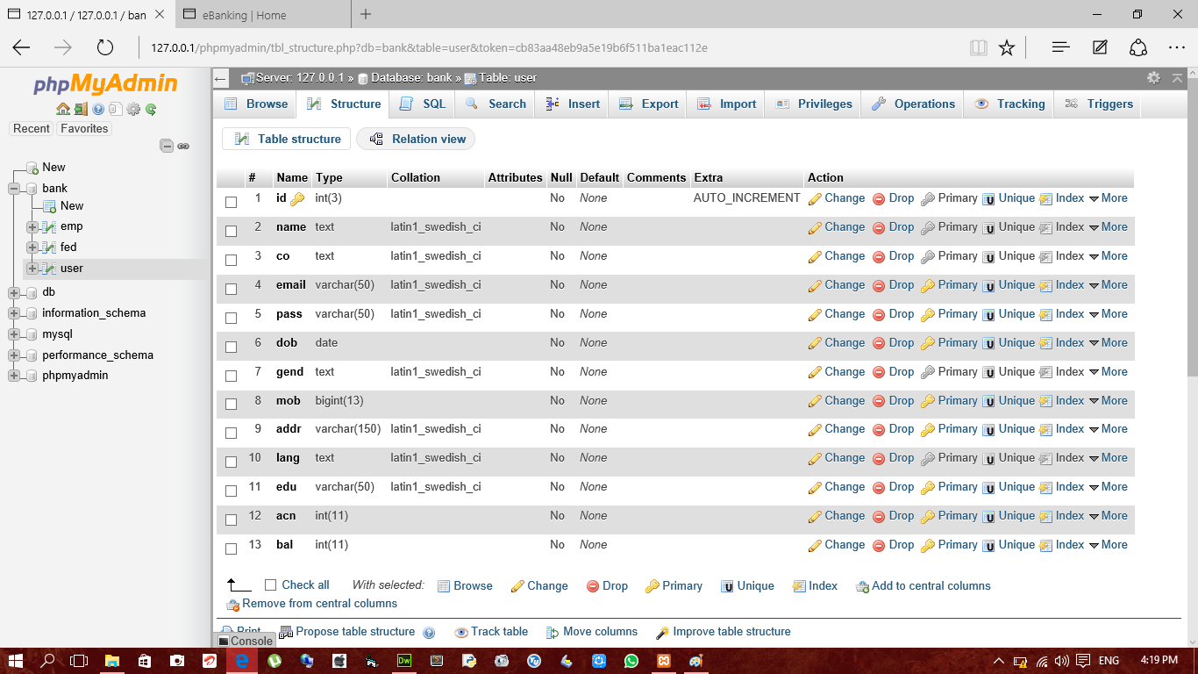

**User registration table data**

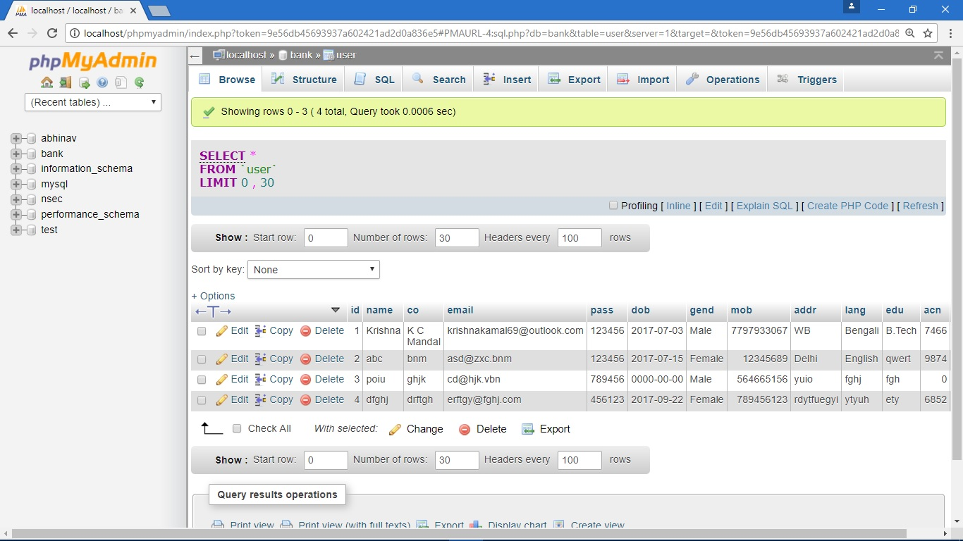

**3. Employee table definition**

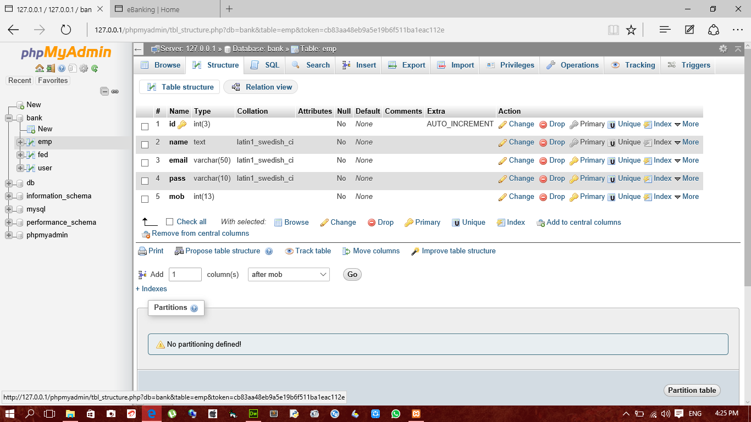

**Employee table data**

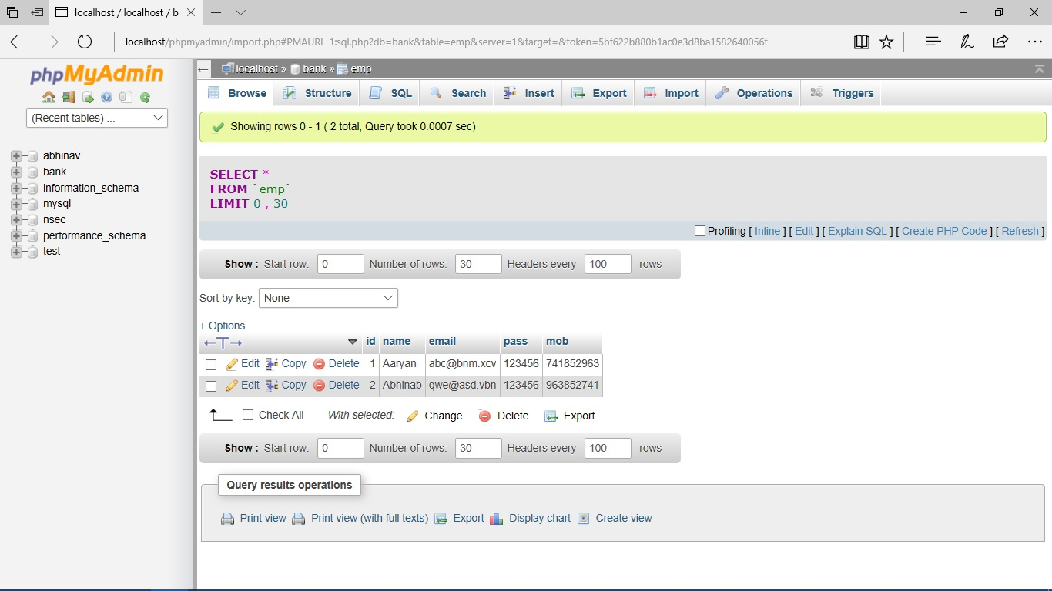

**3. Feedback definition**

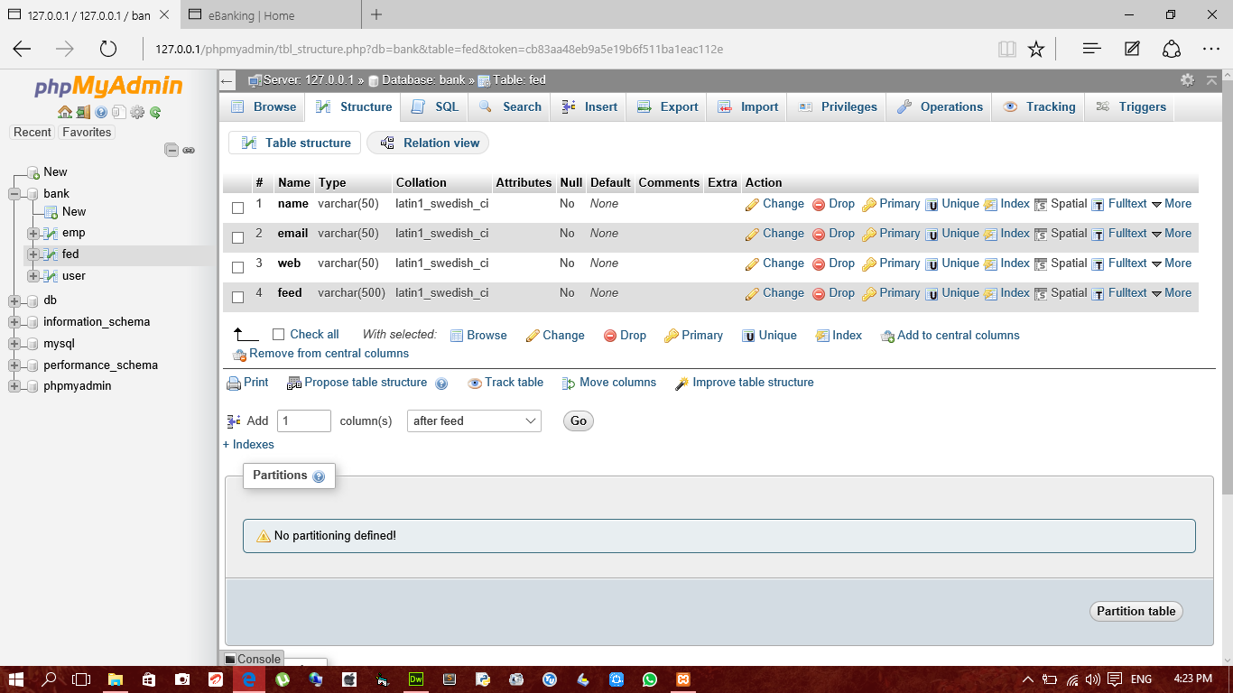

**Feedback table data**

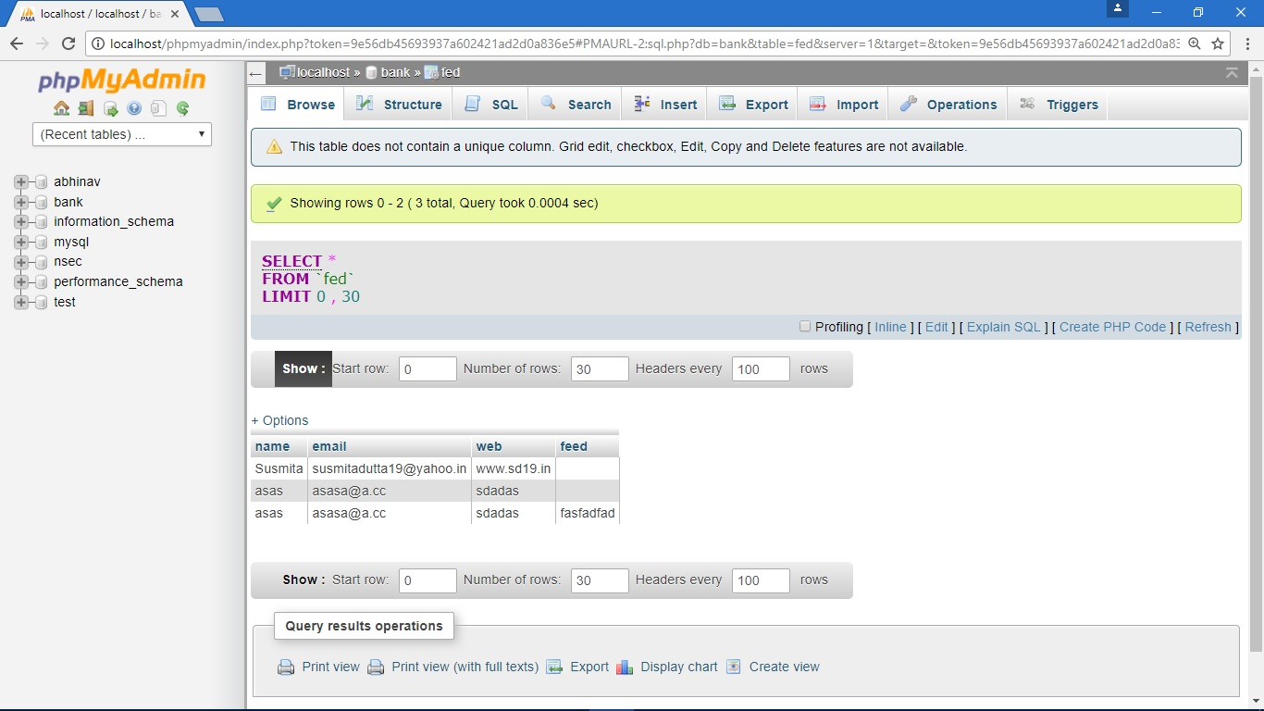

**4.6 USER INTERFACE DESIGN**

**User interface design (UID)** or **user interface engineering** is the [design](http://en.wikipedia.org/wiki/Design) of [user interfaces](http://en.wikipedia.org/wiki/User_interface) for [machines](http://en.wikipedia.org/wiki/Machine) and [software](http://en.wikipedia.org/wiki/Software), such as computers, [home appliances](http://en.wikipedia.org/wiki/Home_appliance), [mobile devices](http://en.wikipedia.org/wiki/Mobile_device), and other [electronic devices](http://en.wikipedia.org/wiki/Electronics), with the focus on maximizing the [user experience](http://en.wikipedia.org/wiki/User_experience). The goal of user interface design is to make the user's interaction as simple and efficient as possible, in terms of accomplishing user goals ([user-centered design](http://en.wikipedia.org/wiki/User-centered_design)).

Good user interface design facilitates finishing the task at hand without drawing unnecessary attention to it. [Graphic design](http://en.wikipedia.org/wiki/Graphic_design) and typography are utilized to support its [usability](http://en.wikipedia.org/wiki/Usability), influencing how the user performs certain interactions and improving the aesthetic appeal of the design; design aesthetics may enhance or detract from the ability of users to use the functions of the interface. The design process must balance technical functionality and visual elements (e.g., [mental model](http://en.wikipedia.org/wiki/Mental_model)) to create a system that is not only operational but also usable and adaptable to changing user needs.

Interface design is involved in a wide range of projects from computer systems, to cars, to commercial planes; all of these projects involve much of the same basic human interactions yet also require some unique skills and knowledge. As a result, designers tend to specialize in certain types of projects and have skills centered on their expertise, whether that be [software design](http://en.wikipedia.org/wiki/Software_design), user research, [web design](http://en.wikipedia.org/wiki/Web_design), or [industrial design](http://en.wikipedia.org/wiki/Industrial_design).

**SNAPSHOTS**

**HOME PAGE:-**

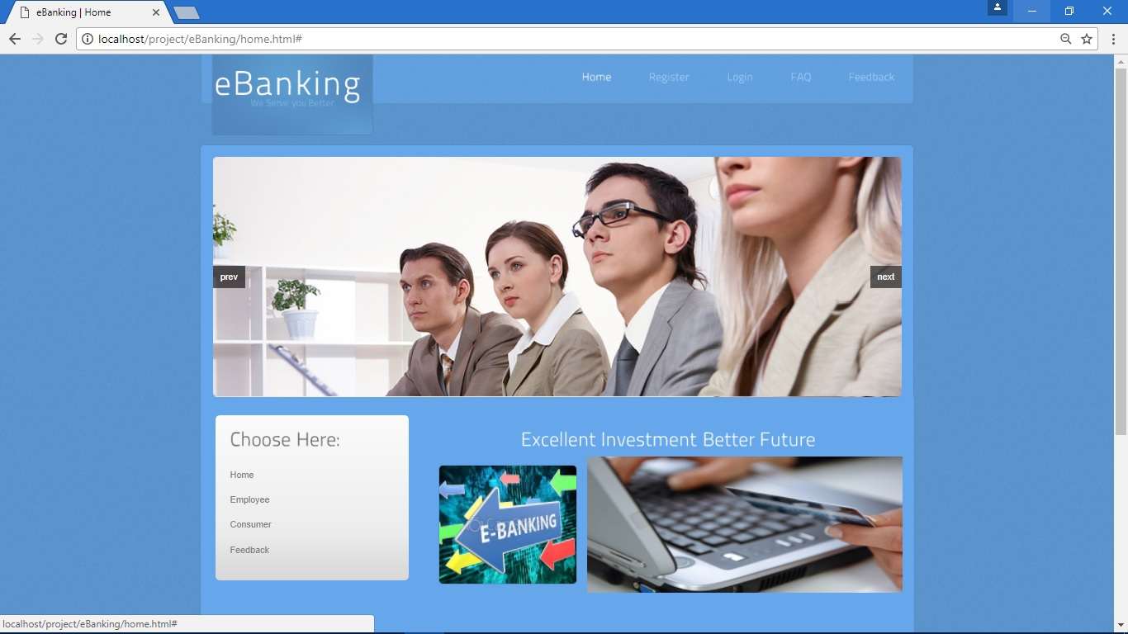

**CODING**

<title>eBanking | Home</title>

<meta http-equiv="Content-Type" content="text/html; charset=utf-8" />

<link href="css/style.css" rel="stylesheet" type="text/css" />

<link rel="stylesheet" type="text/css" href="css/coin-slider.css" />

<script type="text/javascript" src="js/cufon-yui.js"></script>

<script type="text/javascript" src="js/cufon-titillium-250.js"></script>

<script type="text/javascript" src="js/jquery-1.4.2.min.js"></script>

<script type="text/javascript" src="js/script.js"></script>

<script type="text/javascript" src="js/coin-slider.min.js"></script>

</head>

<body>

<div class="main indexpage">

<div class="header">

<div class="header_resize">

<div class="menu_nav">

<ul>

**LOGIN:-**

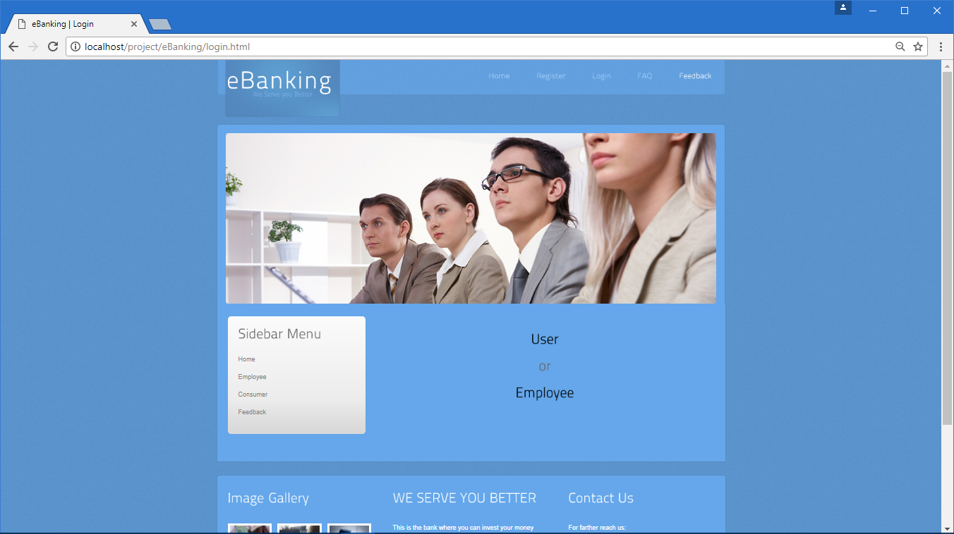

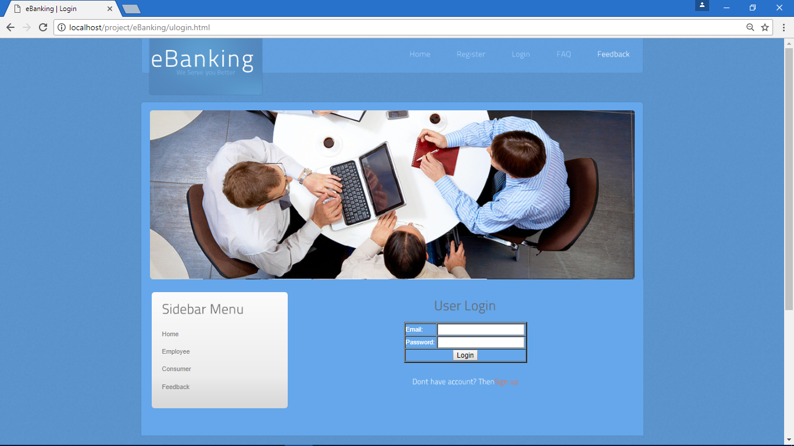

**CODING**

<? php

$a=$_POST['email'];

$b=$_POST['pass'];

$r=mysql_query("select *from user where email='$a' and pass='$b'");

$row=mysql_fetch_array($r);

$_SESSION['jdv']=$row;

if($row['email']==$a && $row['pass']==$b)

{

header("location:profile.php?msg=Login Successfull!");

}

else

{

header("location:ulogin.html?msg=Login failed!");

}

?> $a=$_POST['email'];

$b=$_POST['pass'];

$r=mysql_query("select *from emp where email='$a' and pass='$b'");

$row=mysql_fetch_array($r);

$_SESSION['jdv']=$row;

if($row['email']==$a && $row['pass']==$b)

{

header("location:manage.php?msg=Login Successfull!");

}

else

{

header("location:elogin.html?msg=Login failed!");

}

?>

<a href="#"><img src="images/x.jpg" height="184" width="425px"/></a></div>

**USER REGISTRATION**

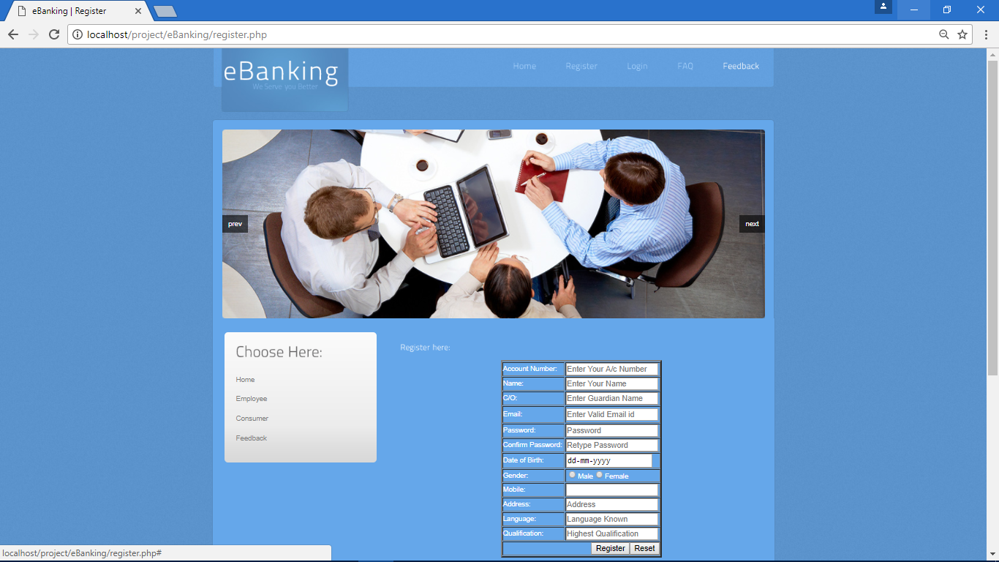

**CODING**

</div>

<div class="clr"></div>

</div>

</div>

<div class="fbg">

<div class="fbg_resize">

<div class="col c1">

<h2><span>Image</span> Gallery</h2>

<a href="#"><img src="images/gal1.jpg" width="75" height="75" alt="" class="gal" /></a> <a href="#"><img src="images/gal2.jpg" width="75" height="75" alt="" class="gal" /></a> <a href="#"><img src="images/gal3.jpg" width="75" height="75" alt="" class="gal" /></a> <a href="#"><img src="images/gal4.jpg" width="75" height="75" alt="" class="gal" /></a> <a href="#"><img src="images/gal5.jpg" width="75" height="75" alt="" class="gal" /></a> <a href="#"><img src="images/gal6.jpg" width="75" height="75" alt="" class="gal" /></a> </div>

<div class="col c2">

<h2><span>WE SERVE YOU</span> BETTER</h2>

<p>This is the bank where you can invest your money securely & get the better facilities than others.We serve you 24*7.</p>

</div>

<div class="col c3">

<h2><span>Contact</span> Us</h2>

<p>For farther reach us:</p>

<p class="contact_info"> <span>Address:</span> a-1/20,Ramgarh,Kolkata-16,India<br />

<span>Telephone:</span> 03222-285071<br />

<span>FAX:</span> 03222-285071<br />

<span>Others:</span> 03222-285075<br />

<span>E-mail:</span> <a href="#">mail@ebanking.com</a> </p>

</div>

<div class="clr"></div>

</div>

</div>

<div class="footer">

<div class="footer_resize">

<!--<p class="lf">Copyright &copy; <a href="#">Domain Name</a>. All Rights Reserved</p>-->

<p class="rf"><center>Design by:<a target="_blank" href="#">@eBanking</a></p></center>

<div style="clear:both;"></div>

</div>

</div>

**F&Q:-**

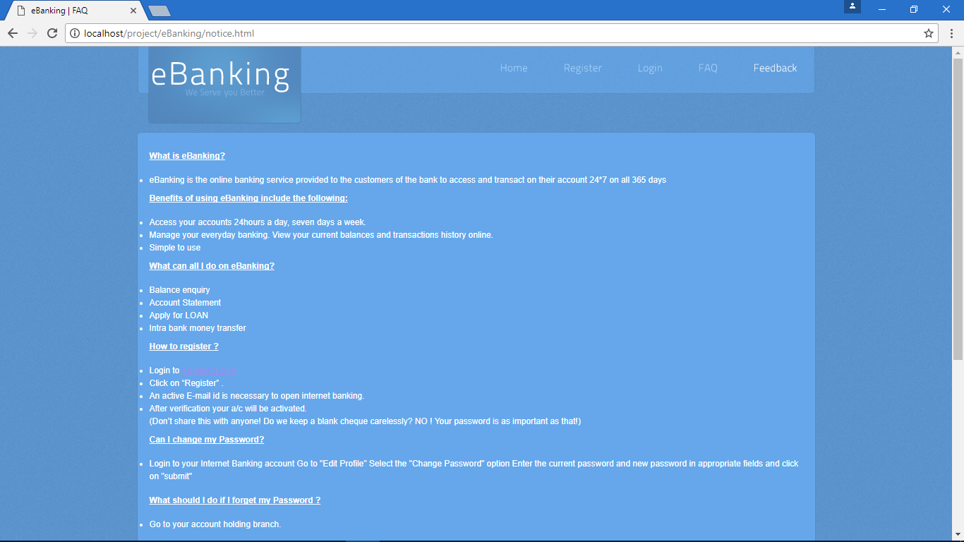

**CODING:-**

$g=mysql_query("select * from user where acn='$x'");

if(mysql_num_rows($g))

{

$usan=$_SESSION['jdv']['acn'];

$res=mysql_query("select * from user where acn='$usan'");

$row=mysql_fetch_array($res);

$d=$row['bal'];

$b=$d-$y;

$f=mysql_query("update user set bal='$b' where acn='$usan'");

$res1=mysql_query("select * from user where acn='$x'");

$rq=mysql_fetch_array($res1);

$e=$rq['bal'];

$u=$y+$e;

$t=mysql_query("update user set bal='$u' where acn='$x'");

if($f==1)

{

header("location:fund.php?msg=Successful!");

}

else

**FEEDBACK:-**

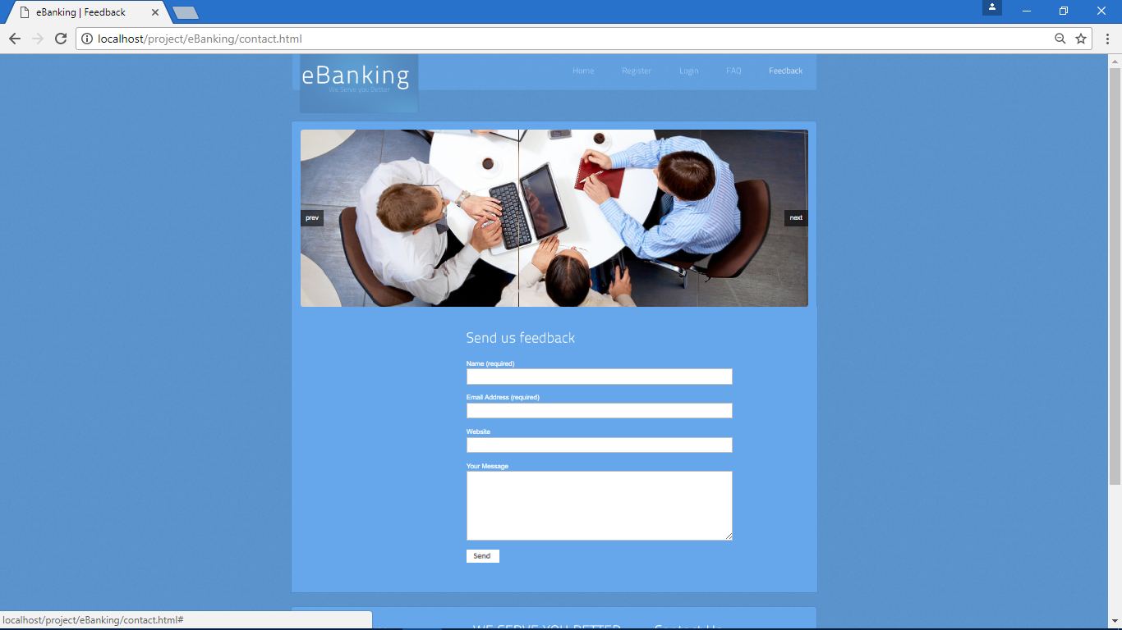

**CODING:-**

<?php

$e=$_POST['email'];

$mas=$_POST['massage'];

$q=mysql_query("select * from user where email='$e'");

$p=mysql_fetch_array($q);

if($p['email']==$e)

{

$r=mysql_query("insert into user (fed) values ('$mas') where email='$e'");

header("location:contact.html?msg=Submitted!");

}

else

{

header("location:contact.html?msg=Not Submitted!");

}

?>

**WHY RESPONSIVE WEBSITE ?**

We have designed a fully responsive website with the help of bootstrap and jQuery. Now a day’s smartphones, tablets and other gadgets are most widely used and every user would fancy all web activity to be done through those gadgets. Hence, we have come forward with this idea of a fully responsive website with a responsive menu which automatically fits the website in any screen size and readjusts its components as and when required, be it smartphone, tablet, phablet or any other gadget.

IMPLEMENTATION

AND

TESTING

**IMPLEMENTATION AND TESTING**

A software system test plan is a document that describes the objectives, scope, approach and focus of software testing effort. The process of preparing a test plan is a usual way to think the efforts needed to validate the acceptability of a software product. The complete document will help people outside the test group understand the "WHY" and "HOW" product validation. It should be through enough to be useful but not so through that no one outside the test group will read it.

**5.1 INTRODUCTION**

Testing is the process of running a system with the intention of finding errors. Testing enhances the integrity of a system by detecting deviations in design and errors in the system. Testing aims at detecting error-prone areas. This helps in the prevention of errors in a system. Testing also adds value to the product by conforming to the user requirements.

The main purpose of testing is to detect errors and error-prone areas in a system. Testing must be thorough and well-planned. A partially tested system is as bad as an untested system. And the price of an untested and under-tested system is high.

The implementation is the final and important phase. It involves user-training, system testing in order to ensure successful running of the proposed system. The user tests the system and changes are made according to their needs. The testing involves the testing of the developed system using various kinds of data. While testing, errors are noted and correctness is the mode.

**5.2 OBJECTIVES OF TESTING**

The objective our test plan is to find and report as many bugs as possible to improve the integrity of our program. Although exhaustive testing is not possible, we will exercise a broad range of tests to achieve our goal. Our user interface to utilize these functions is designed to be user-friendly and provide easy manipulation of the tree. The application will only be used as a demonstration tool, but we would like to ensure that it could be run from a variety of platforms with little impact on performance or usability.

**Process Overview**

The following represents the overall flow of the testing process:

1. Identify the requirements to be tested. All test cases shall be derived using the current Program Specification.

2. Identify which particular test(s) will be used to test each module.

3. Review the test data and test cases to ensure that the unit has been thoroughly verified and that the test data and test cases are adequate to verify proper operation of the unit.

4. Identify the expected results for each test.

5. Document the test case configuration, test data, and expected results.

6. Perform the test(s).

7. Document the test data, test cases, and test configuration used during the testing process. This information shall be submitted via the Unit/System Test Report (STR).

8. Successful unit testing is required before the unit is eligible for component integration/system testing.

9. Unsuccessful testing requires a Bug Report Form to be generated. This document shall describe the test case, the problem encountered, its possible cause, and the sequence of events that led to the problem. It shall be used as a basis for later technical analysis.

10. Test documents and reports shall be submitted. Any specifications to be reviewed, revised, or updated shall be handled immediately.

**5.3 TEST CASES**

A test case is a document that describe an input, action, or event and expected response, to determine if a feature of an application is working correctly. A test case should contain particular such as test case identifier, test condition, input data

Requirement expected results. The process of developing test cases can help find problems in the requirement or design of an application, since it requires completely thinking through the operation of the application.

**TESTING STEPS**

**Unit Testing**

Unit testing focuses efforts on the smallest unit of software design. This is known as module testing. The modules are tested separately. The test is carried out during programming stage itself. In this step, each module is found to be working satisfactory as regards to the expected output from the module.

**Integration Testing**

Data can be lost across an interface. One module can have an adverse effect on another, sub functions, when combined, may not be linked in desired manner in major functions. Integration testing is a systematic approach for constructing the program structure, while at the same time conducting test to uncover errors associated within the interface. The objective is to take unit tested modules and builds program structure. All the modules are combined and tested as a whole.

**Validation**

At the culmination of the integration testing, Software is completely assembled as a package. Interfacing errors have been uncovered and corrected and a final series of software test begin in validation testing. Validation testing can be defined in many ways, but a simple definition is that the validation succeeds when the software functions in a manner that is expected by the customer. After validation test has been conducted, one of the three possible conditions exists.

a) The function or performance characteristics confirm to specification and are accepted.

b) A deviation from specification is uncovered and a deficiency lists is created.

c) Proposed system under consideration has been tested by using validation test and found to be working satisfactory.

|  |  |  |  |
| --- | --- | --- | --- |
| **Tested By:** | | Amandeep Singh | |
| **Test Type** | | Unit Testing | |
| **Test Case Number** | | 1 | |
| **Test Case Name** | | User Registration | |
| **Test Case Description** | | The user should enter his/ her accurate information so that he/she can able to go for the further options. The test case will check the application for the same since a user can only login with the correct user id and password. | |
| **Item(s) to be tested** | | | |
| 1 | Verification of the user id and password with the record in the database. | | |
| **Specifications** | | | |
| **Input** | | | **Expected Output/Result** |
| 1. Correct User id and password 2. Incorrect Id or Password | | | 1. Successful login 2. Failure Message |

**SNAPSHOT**



|  |  |  |  |
| --- | --- | --- | --- |
| **Tested By:** | | Aryan Raj | |
| **Test Type** | | Unit Testing | |
| **Test Case Number** | | 2 | |
| **Test Case Name** | | User Login | |
| **Test Case Description** | | A new user will enter his details in the registration form and the credentials will be checked by the validators used in the form. After all the credentials are validated then only the form will be submitted and data will be stored in the database | |
| **Item(s) to be tested** | | | |
| 1 | Required fields in the form are not empty, validation of proper credentials | | |
| **Specifications** | | | |
| **Input** | | | **Expected**  **Output/Result** |
| * 1. User id, name, password, phone, address, email.   2. Empty field, Invalid entry | | | 1. Successful registration 2. Failure Message |

**SNAPSHOT**



**5.4 WHITE BOX TESTING**

In white box testing, the UI is bypassed. Inputs and outputs are tested directly at the code level and the results are compared against specifications. This form of testing ignores the function of the program under test and will focus only on its code and the structure of that code. Test case designers shall generate cases that not only cause each condition to take on all possible values at least once, but that cause each such condition to be executed at least once. To ensure this happens, we will be applying Branch Testing. Because the functionality of the program is relatively simple, this method will be feasible to apply.

Each function of the binary tree repository is executed independently; therefore, a program flow for each function has been derived from the code.

**5.5 BLACK BOX TESTING**

Black box testing typically involves running through every possible input to verify that it results in the right outputs using the software as an end-user would. We have decided to perform Equivalence Partitioning and Boundary Value Analysis testing on our application.

System Testing

The goals of system testing are to detect faults that can only be exposed by testing the entire integrated system or some major part of it. Generally, system testing is mainly concerned with areas such as performance, security, validation, load/stress, and configuration sensitivity. But in our case well focus only on function validation and performance. And in both cases, we will use the black-box method of testing.

**5.6 OUTPUT TESTING**

After performing the validation testing, the next step is output testing of the proposed system, since no system could be useful if it does not produce the required output in a specific format. The output format on the screen is found to be correct. The format was designed in the system design time according to the user needs. For the hardcopy also; the output comes as per the specified requirements by the user. Hence output testing did not result in any correction for the system.

**5.7 User Acceptance Testing**

User acceptance of a system is the key factor for the success of any system. The system under consideration is tested for the user acceptance by constantly keeping in touch with the prospective system users at the time of developing and making changes whenever required.

This is done in regard to the following point:

a) Input Screen Design

b) Output Screen Design

c) Format of reports and other outputs.

**5.8 INTEGRATION TESTING**

Software testing is always used in association with verification and validation. In the testing phase of this project our aim is to find the answer to following two questions.

* Whether the software matches with the specification (i.e.process base) to verify the product.
* Whether this software in one client what wants (i.e. product base) to validate the product.
* Unit testing and integration testing has been carried out to find the answer to above questions. In unit testing each individual module was test to find any unexpected behaviour if exists. Later all the module was integrated and flat file was generated.

**FUNCTIONAL TESTING**

These are the points concerned during the stress test:

* Nominal input: character is in putted in the place of digits and the system has to flash the message "Data error"
* Boundary value analysis: exhaustive test cases have designed to create an output report that produces the maximum (and minimum) allowable number of table entries.

**6 GANTT CHART(Editing Required)**

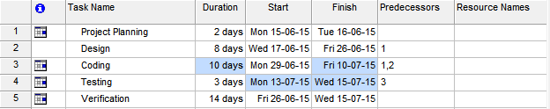

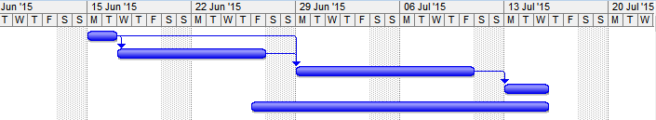

SOFTWARE SYTEM ATtRIBUTES

**7.1 DATABASE SECURITY**

System security measure is meant to be provided to make your system reliable and secured from unauthorized user may create threats to the system. So you should follow some security measures. We have used security levels in database level at system level.

**7.2 SYSTEM SECURITY**

If we talk about the system security in our proposed system we have implemented with the help of maintain the session throughout the system’s use. Once a user has logged out than he/she will not be able to perform any task before signing back again.

A high level of authentic login is given to the system so this is a very tedious task to enter without authorization and authentication.

**7.3 LIMITATIONS**

* Since it is an online project, customers need internet connection to use it.
* People who are not familiar with computers can’t use this software.
* Customer must have debit card or credit card to book tickets.

**8. CONCLUSION**

This project has been appreciated by all the users in the organization. It is easy to use, since it uses the GUI provided in the user dialog. User friendly screens are provided.The usage of software increases the efficiency, decreases the effort. It has been efficiently employed as a Site management mechanism. It has been thoroughly tested and implemented.

The project **“e-Banking System”** is the ideal Project for every customer who will get all the information about the e-Banking System, how to manage his account, doing fund transfer etc. It will provide user the benefit e-Banking with giving enough facility one click away sitting in his home without having to make the long walk and standing in queues.

The software collects the credit card information of the user and it provides a secure gateway for all kinds of transaction online. The software provides a reliable platform for keeping all sensitive information. For this kind of online business, the special software must be installed on the server(and the gateway for paymentas) which host the site, or on a secure server which receives all sensitive data.

**9 FUTURE SCOPE AND FURTHER ENHANCEMENTS**

In future, we would like to keep working on this project and make new additions to provide users with more advanced features and more detailed information. We have set our sights on the following additions in future-

1. Addition of live score board on match day
2. Information and stats about each and every match on a daily basis
3. Addition of other UEFA competitions like: UEFA Europa League, UEFA Euro, UEFA Women’s Champions League.
4. User will have an option of buying official club merchandise online through our shopping system we will introduce

**10 REFERENCES**

1. <https://www.w3schools.com>
2. <https://www.slideshare.com>
3. <https://www.scribd.com>
4. <https://www.tutorialspoint.com>
5. https://www.youtube.com

THANK YOU